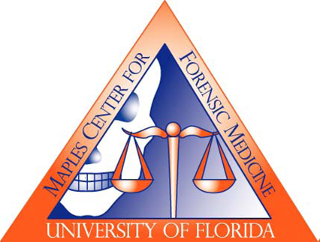
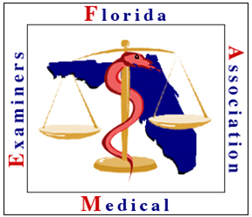
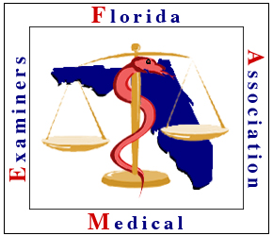
EXHIBITOR TABLE RESERVATION FORM
46th Annual Educational Conference of the
Florida Association of Medical Examiners
July 10-12, 2019
Eau Palm Beach Resort & Spa
Manalapan, Florida

TABLE INFORMATION:
The submission of the Exhibitor Table Reservation Form will confirm a “hold” on a table or tables and acknowledge participation in the 2019 FAME Conference. Exhibitors will be assured booth space by reserving early.
The cost per exhibit table is $750. Breakfast, as well as morning and afternoon breaks will be held in the exhibit area to increase traffic. The exhibit area is adjacent to the meeting room. Sponsoring companies receive priority placement, followed by those first to submit the reservation form with payment. Sponsorship opportunities are described on the next page.
Meeting badges are required for all scientific, food/beverage and social functions. One complimentary badge with full registration is included with each Exhibitor table reserved. Additional booth attendant registrations can be purchased at a cost of $425 each. No one is allowed in the exhibit room or General Session without a paid registration.
#1 Complimentary Booth Attendee Name
#2 Additional Booth Attendee Name
#3 Additional Booth Attendee Name

COMPANY CONTACT INFORMATION:

Company Name
Contact
Company Address
Phone E-mail

EXHIBITOR OPTIONS:
Primary booth attendee #___@$750 = $____
Additional booth attendees #___@$425 = $____

Sponsors and Exhibitors will be recognized by signage displayed at the registration desk and by projection during breaks.
Please contact the Dr. Bruce Goldberger (bruce-goldberger@ufl.edu) for additional information regarding availability.

IMPORTANT NOTES:
This reservation provides confirmation that your company plans to exhibit at FAME 2019 in Manalapan, Florida. Refunds, minus a $50 fee, will be honored upon written request prior to July 1, 2019. There will be no refunds after July 1, 2019.

E-MAIL the Exhibitor Table Reservation Form and the Exhibit Application to bruce-goldberger@ufl.edu and evansj@ufl.edu, for date-stamped priority placement. Make check payable to the “University of Florida” and MAIL CHECK PAYMENT PROMPTLY with a copy of this form to:
University of Florida, Continuing Medical Education, PO Box 100233, Gainesville, FL 32610-0233

FAME 2019 Sponsorship Opportunities:
Note: A Letter of Agreement form is also required for Sponsorship.

Gold Level Supporters ($2,000):
- Sponsorship of a break and the Thursday night dinner event

Silver Level Supporters ($1,500):
- Sponsorship of a break and the Wednesday night opening reception event

Blue Level Supporters ($1000):
- Sole sponsorship of a breakfast

Orange Level Supporters ($500):
- Shared sponsorship of a break

Set-up is scheduled for Wednesday, July 10, 2019 from 7:00 AM to 8:30 AM. Please see Ricardo Camacho at the Registration Desk for table assignment and other details regarding the conference.

Additional Sponsorship Opportunities:
If you are interested in sponsoring conference items, such as lanyards, notebooks, or flash drives, please contact Dr. Bruce Goldberger at bruce-goldberger@ufl.edu, (352) 627-2001.

